Case 2-A2056-Egy-Karnak-Akenaten-Head-Terracotta-Karnak-ca 1336 BCE

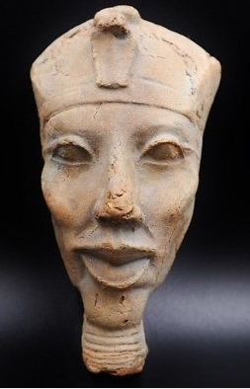 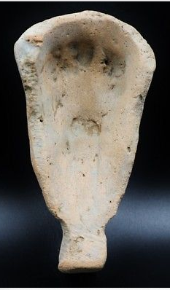

**Case no.: 2**

**Accession Number: A2056**

**Formal Label:**

**Display Description:**

Akhenaten (Akhenaton "Effective for Aten"), known before the fifth year of his reign as Amenhotep IV (in Greek: *Amenophis IV* meaning "Amun Is Satisfied"), was a pharaoh of the 18th Dynasty who ruled for 17 years 1319-1336 BCE or 1317-1334 BCE. The 18th Dynasty was recovering from the hegemony of the Hyksos during the second Intermediate Period so the time was ripe for a reinvigorated approach to Egyptian power.

In this quest Akhenaten abandoned traditional Egyptian polytheism and substituted worship centered on the solar deity Aten, which he likened to the Sun as compared to stars that he believed received their light from it and he likened the stars to the traditional gods. Thus, he was to develop a centralized religion in which the revenues and powers of the priests who derived their powers from the stars would be subsumed in a centralized hierarchy dedicated to one overarching deity, Aten, who derived his powers from the single celestial orb, the Sun. This theological shift, while intended to reinvigorate the Egyptian sense of lost influence, ran counter to the cultic god cults and their priesthoods, who recognized they would suffer loss of their revenues and powers. Thus, Akhenaten’s theological innovation ran counter to the hierarchy of the priestly establishment.

In addition, Akhenaten’s iconography diverged radically from traditional Egyptian monumentality. Akhenaten’s feminine body and elongated face challenged the sexuality of male rulers who peered at their audiences with a serene but power-encapsulated physiogamy that exuded strength and inflexible deliberateness. Akhenaten’s physiogamy exuded none of these traits. In comparison, he looked effeminate and weak.

However, as with any new pharaoh, Akhenaten established a building program to erect structures in praise of himself. In the large open court that was part of the temple to Aten east of the enclosure wall of the temple of Karnak, probably 32, 4m-high, sandstone colossi of his likeness were erected (Manniche 2010:x). All of these sculptures embodied his peculiar physiogamy that deviated from traditional Egyptian iconography. Gone was the artistic projection of the ruler’s powerful, unchallenged and ineffable godlike power, a power which now rested with the Solar Disk that all could worship daily in the heavens. This was a democratization of theology, a theology that had previously been jealously guarded by the priests who had been its only intermediaries.

Furthermore, Akhenaten produced a theologically comprehensive and aesthetically beautiful *Great Hymn to Aten*, which began (Pritchard 1958: 227-230.):

How manifold it is, what thou hast made!

They are hidden from the face [of man].

O sole god, like whom there is no other!

Thou didst create the world according to thy desire,

Whilst thou wert alone: All men, cattle, and wild beasts,

Whatever is on earth, going upon [its] feet,

And what is on high, flying with its wings.

Sir Flinders Petrie wrote in 1898 (2:214):

If this were a new religion, invented to satisfy our modern scientific conceptions, we could not find a flaw in the correctness of this view of the energy of the solar system. How much Akhenaten understood, we cannot say, but he certainly bounded forward in his views and symbolism to a position which we cannot logically improve upon at the present day. Not a rag of superstition or of falsity can be found clinging to this new worship evolved out of the old Aton of Heliopolis, the sole Lord of the universe.

This *Great Hymn to Aten* is the longest of those poems written to the sun-disk deity Aten:

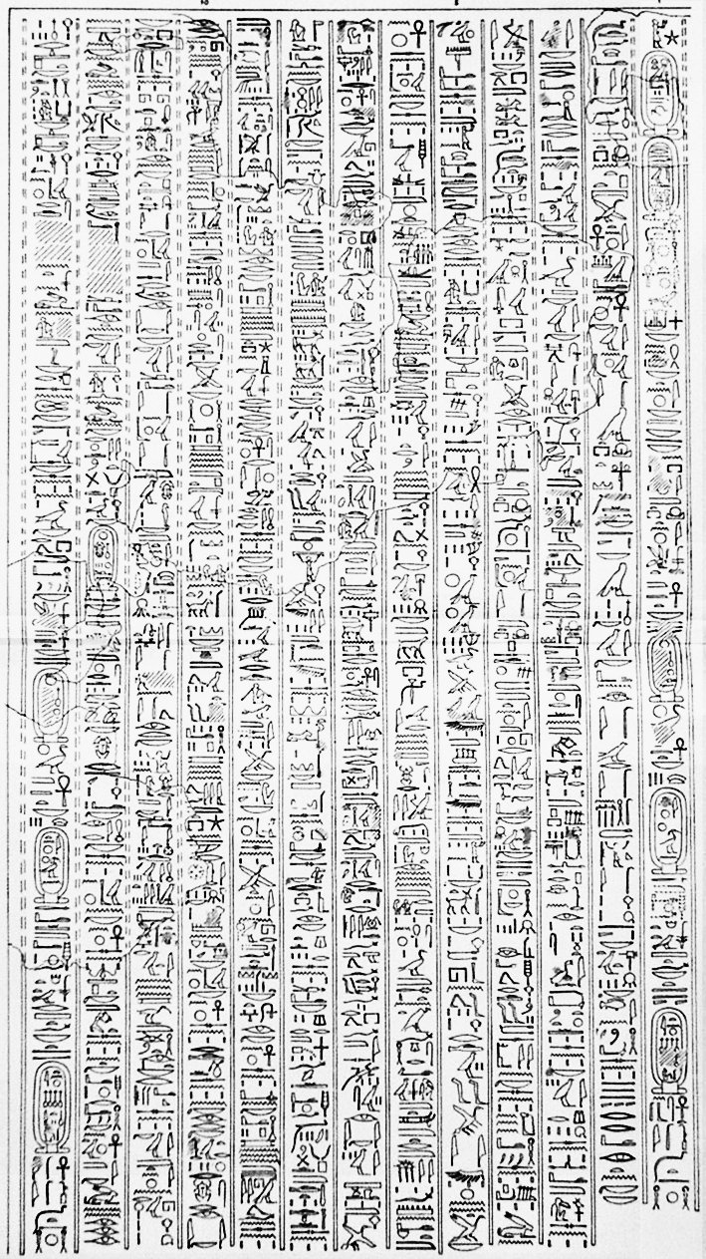

Amehotep IV (Akhenaten), *Great Hymn to Aten* in N. de G. Davies, *The Rock Tombs of El Amarna*, part VI, "The Egypt Exploration Fund" (London, 1908) - <http://www.sofiatopia.org/equiaeon/davies.htm> (greater contrast)

In 1907, simultaneous with Flinders Petrie’s excavations of Akhenaten’s city of Akhenaten at Amarna, Edward R. Ayrton excavating in the Valley of the Kings at Luxor found a mummy d in tomb KV55, which, based on DNA analysis, is probably that of Akhenaten (Anon. 2000*; but cf.* Anon 2010). This was buried hurriedly without proper identification. Across the Nile at Karnak rested Akhenaten’s causeway of statues to himself and his temple to Aten. However, when Akhenaten had died after only 17 years into his reign, efforts to dismantle and secrete his monuments and statues were enacted by the priestly establishment. Purposefully, they effaced his name and excluded it from traditional Pharaonic lists (Manniche 2010: ix). These same priests restored the traditional Egyptian gods and goddesses, which would henceforth ensure continuing revenues and jurisdictional power by the priests over the shrines of these deities.

**LC Classification:** DT62

**Date or Time Horizon:** 18th dynasty, 1550-1295 BCE

**Geographical Area:** Karnak

**Map:**

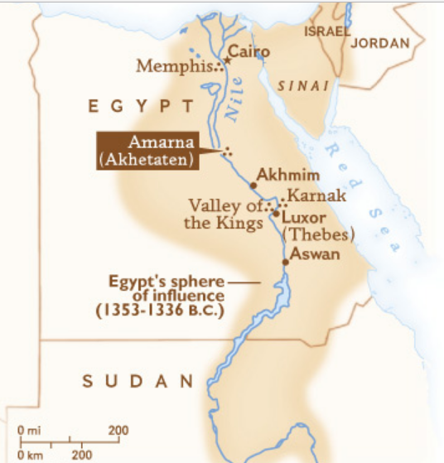

**Map of Egypt ca. 1336 BCE after http://arclab.usc.edu/barracks/Images/amarnamap.jpg**

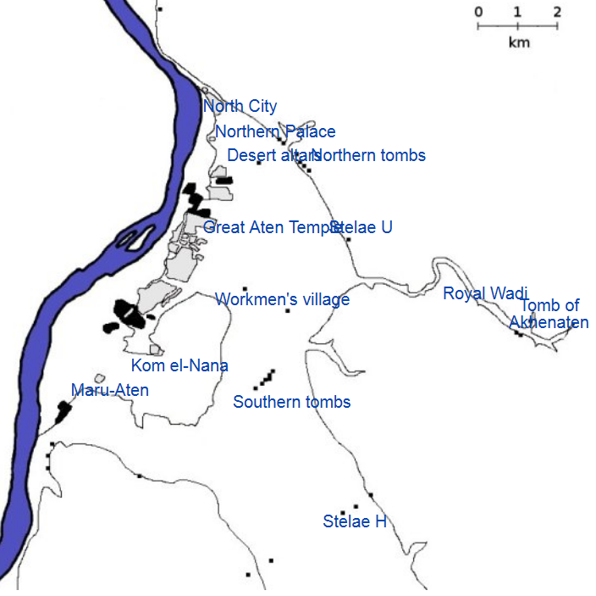

**El Amarna map after http://www.narmer.pl/map/ima/ama_m_en.gif.**

**GPS coordinates:** [27°38′42.71″N30°53′47.34″E](https://tools.wmflabs.org/geohack/geohack.php?pagename=Amarna&params=27_38_42.71_N_30_53_47.34_E_type:landmark)

**Cultural Affiliation:** 18th Dynasty

**Medium:** terracotta

**Dimensions:**

**Weight:**

**Condition: original**

**Provenance:**

**Discussion:**

Construction of Amarna started in or around Year 5 of Akenaten’s reign (1346 BC) and was probably completed by Year 9 (1341 BC), although it became the capital city two years earlier. To speed up construction of the city most of the buildings were constructed out of mud-brick, and white washed. The most important buildings were faced with local stone.[[10]](https://en.wikipedia.org/wiki/Amarna#cite_note-10)

It is the only ancient Egyptian city which preserves great details of its internal plan, in large part because the city was abandoned after the death of Akhenaten, when Akhenaten's son, King Tutankhamun, decided to leave the city and return to his birthplace in Thebes (modern Luxor). The city seems to have remained active for a decade or so after his death, and a shrine to Horemheb indicates that it was at least partially occupied at the beginning of his reign,[[11]](https://en.wikipedia.org/wiki/Amarna#cite_note-kemp-11) if only as a source for building material elsewhere. Once it was abandoned it remained uninhabited until Roman settlement[[4]](https://en.wikipedia.org/wiki/Amarna#cite_note-roman-4) began along the edge of the Nile.

**References:**

Aldred, Cyril. 1988. *Akhenaten: King of Egypt.* London: Thames and Hudson*.*

Anon. 2000. “[KV 55 Mummy & Tutankhamen*"*](http://anubis4_2000.tripod.com/mummypages1/18C.htm). Anubis 4(2000)tripod.com

Anon. 2010.["News from the Valley of the Kings: DNA Shows that KV55 Mummy Probably Not Akhenaten"](http://www.kv64.info/2010/03/dna-shows-that-kv55-mummy-probably-not.html)

David, Rosalie. 1998. *Handbook to Life in Ancient Egypt.* New York: Facts on File*.*

de Garis Davies, Norman. 1903–1908*. The Rock Tombs of El Amarna. Part 1–6. London: EES.*

Eyma, Aayko, ed. 2003. *A Delta-Man in Yebu*. Universal-Publishers.

*Grundon, Imogen (2007). The Rash Adventurer, A Life of John Pendlebury. London: Libri.*

Hess, Richard S. (1996). *Amarna Personal Names*. Winona Lake, IN: Dissertations of the American Schools of Oriental Research - DASOR, 9.

Kemp, Barry. 2012. *The City of Akhenaten and Nefertiti. Amarna and its People*. Thames and Hudson, London.

Manniche, Lise. 2000. *Akhenaten Colossi of Karnak*. Cairo: American University in Cairo Press.

Martin, G. T. 1989. [1974]. *The Royal Tomb at el-'Amarna. 2 vols. London: EES.*

Moran, William L. 1992. *The Amarna Letters. Baltimore: Johns Hopkins University Press.*

Petrie, Sir Flinders. 1899. *History of Egypt.* London. 2v.

Pritchard, James B., ed., *The Ancient Near East – Volume 1: An Anthology of Texts and Pictures*. Princeton, New Jersey: Princeton University Press, 1958, pp. 227-230.):

• *Redford, Donald (1984). Akhenaten: The Heretic King. Princeton.*

• *Waterson, Barbara (1999). Amarna: Ancient Egypt's Age of Revolution.*